C:\Documents and Settings\KCrill\Local Settings\Temporary Internet Files\Content.IE5\5M5SDUUO\MC900188233[1].wmfDirections: Please complete problems 1-4 first. Then go back and try the extensions for each problem (a, b, and c questions). Show your work on a separate piece of paper. Consider all of the math tools you know how to use. (Number line, bar model, ratio table, array, open area model, addition, subtraction, multiplication, and division)

1. The elves are preparing for Christmas. They are making bows for presents from red, green, and white ribbon. They need red strips of ribbon that are 1/4 of a meter, green strips that are 3/4 of a meter, and white strips that are 2/3 of a meter long. They have one spool of each ribbon color. The spools are each 3 meters long. How many bows of each color can they make? Show your work using a visual model.
   1. What if the spools of ribbon were 9 meters long?
   2. What if the spools of ribbon were 12 meters long?
   3. What if the spools of ribbon were 8 meters long?

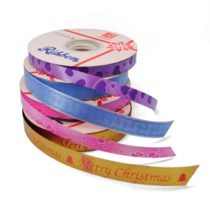

1. The elves want the same number of red and green ribbons. How many spools of red ribbon and green ribbon will they have to use to have an equal amount of both?
   1. What if they wanted twice as many green ribbons as red ribbons?
   2. What if they wanted ½ as many green ribbons as red ribbons?
   3. What if they wanted four times as many red ribbons as green ribbons?

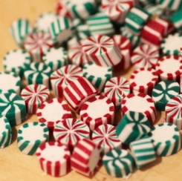

1. The Sweet Tooth Elves are packaging Christmas candy for stockings. They have ¾ pound (lb.) of candy. They want to fill 6 packages of candy equally. How much candy will be in each package?
   1. What if they only had ½ pound of candy for 6 packages?
   2. What if they had 1/5 pound of candy for 4 packages?
   3. What if they had 2/3 pound of candy for 4 packages?

C:\Documents and Settings\KCrill\Local Settings\Temporary Internet Files\Content.IE5\NZE1UH3W\MC900116000[1].wmf

1. C:\Documents and Settings\KCrill\Local Settings\Temporary Internet Files\Content.IE5\MAZVE0MX\MC900357333[1].wmfAfter packaging the candy, the Sweet Tooth Elves began frosting gingerbread houses. They had only 2/5 of a cup of frosting left! They had to share the frosting equally to frost 3 gingerbread houses. How much frosting could each elf use?
   1. What if they only had 1/3 of a cup left for the 3 gingerbread houses?
   2. What if they only had 3/5 of a cup left for 4 gingerbread houses?
   3. What if they had 5/6 of a cup left for 2 gingerbread houses?